Theme: Who am I?

This half term Children explore their new school environment. They will learn about new school routines whilst building their independent skills. They learn how to greet each other and how to build good relationships with friends. They explore how they have changed over time and talk about who is special to them

Words to learn this half term:
Me, family, home, like, love, feel, face, eyes.
mouth, nose, hair, body, favourite, share, cow, pig, horse, sheep, goat, barn, straw, farmer

We will be focusing on feelings, and how to be kind to others.

We will be using all of our senses to explore some
exciting activities such as: cooking, music & modelling.
Stories
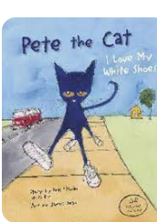
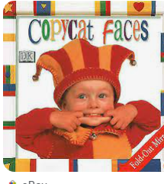
During the half term many of the activities and learning experiences offered will be focussed around some of the following stories:

Happy to be me
Copycat Faces
Pete the Cat

Maths
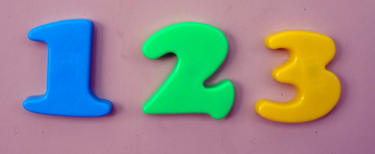
This half term we will be learning about colour, sorting and matching. We will also be learning a range of number rhymes to help us with our counting.

Songs and Rhymes
Children love to sing and dance! Please help your child to learn these rhymes:
-If you’re happy and you know it
-Heads, shoulders, knees and toes
-Shake your sillies out

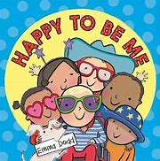

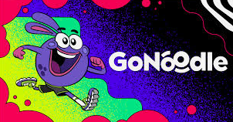
Useful Apps
Go Noodle -YouTube
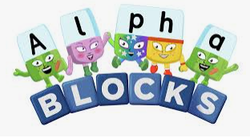
CBeebies Alphablocks
Phonics Play
TopMarks -EYFS

Please remember to:
- Bring your book bag every day.
- Write your child’s name inside all of their uniform.
- Bring a warm coat, hat and scarf to school, as the weather is starting to get colder.
- Ensure your child has spare clothes in school for any little accidents!
- Have a look at our school website for the school holiday list and other useful information
www.cheetwood.manchester.sch.uk
- Home learning is given out every Friday and your child gets a sticker for completing it.
- PE is on a Friday. Please send your child into school that day wearing black shorts/ leggings/ jogging bottoms, a white t shirt, school sweatshirt and trainers. Earrings must be removed.

