FS2 Curriculum News Spring 1 2022
Theme: Fantasy and Polar Regions


This half term we will be finding out and learning about Polar regions, dinosaurs and superheroes. We will also be looking at Chinese New Year and sharing stories with fantasy creatures such as dragons.

Words to learn this half term:
Arctic, cold, frost, snow, frozen, melt, icicles, polar bear, arctic fox, snowy owl, caribou, humpback whale, penguins, blubber, seal, arctic hare, feathers, webbed feet, wings, antlers, Chinese New Year, Chinese dragon, lion, dragons, rooster, red, chop sticks, celebration, dinosaur, swamp, sludge, drum, beat, stomp, fierce, ferocious, Tyrannosaurus Rex, Diplodocus, Triceratops, Stegosaurus, sound, and hear.

We will be using all of our senses to explore some
exciting activities such as: cooking, music, dance & modelling.
Stories
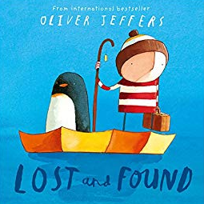
During the half term many of the activities and learning experiences offered will be focussed around some of the following stories:

Polar Bear, Polar Bear
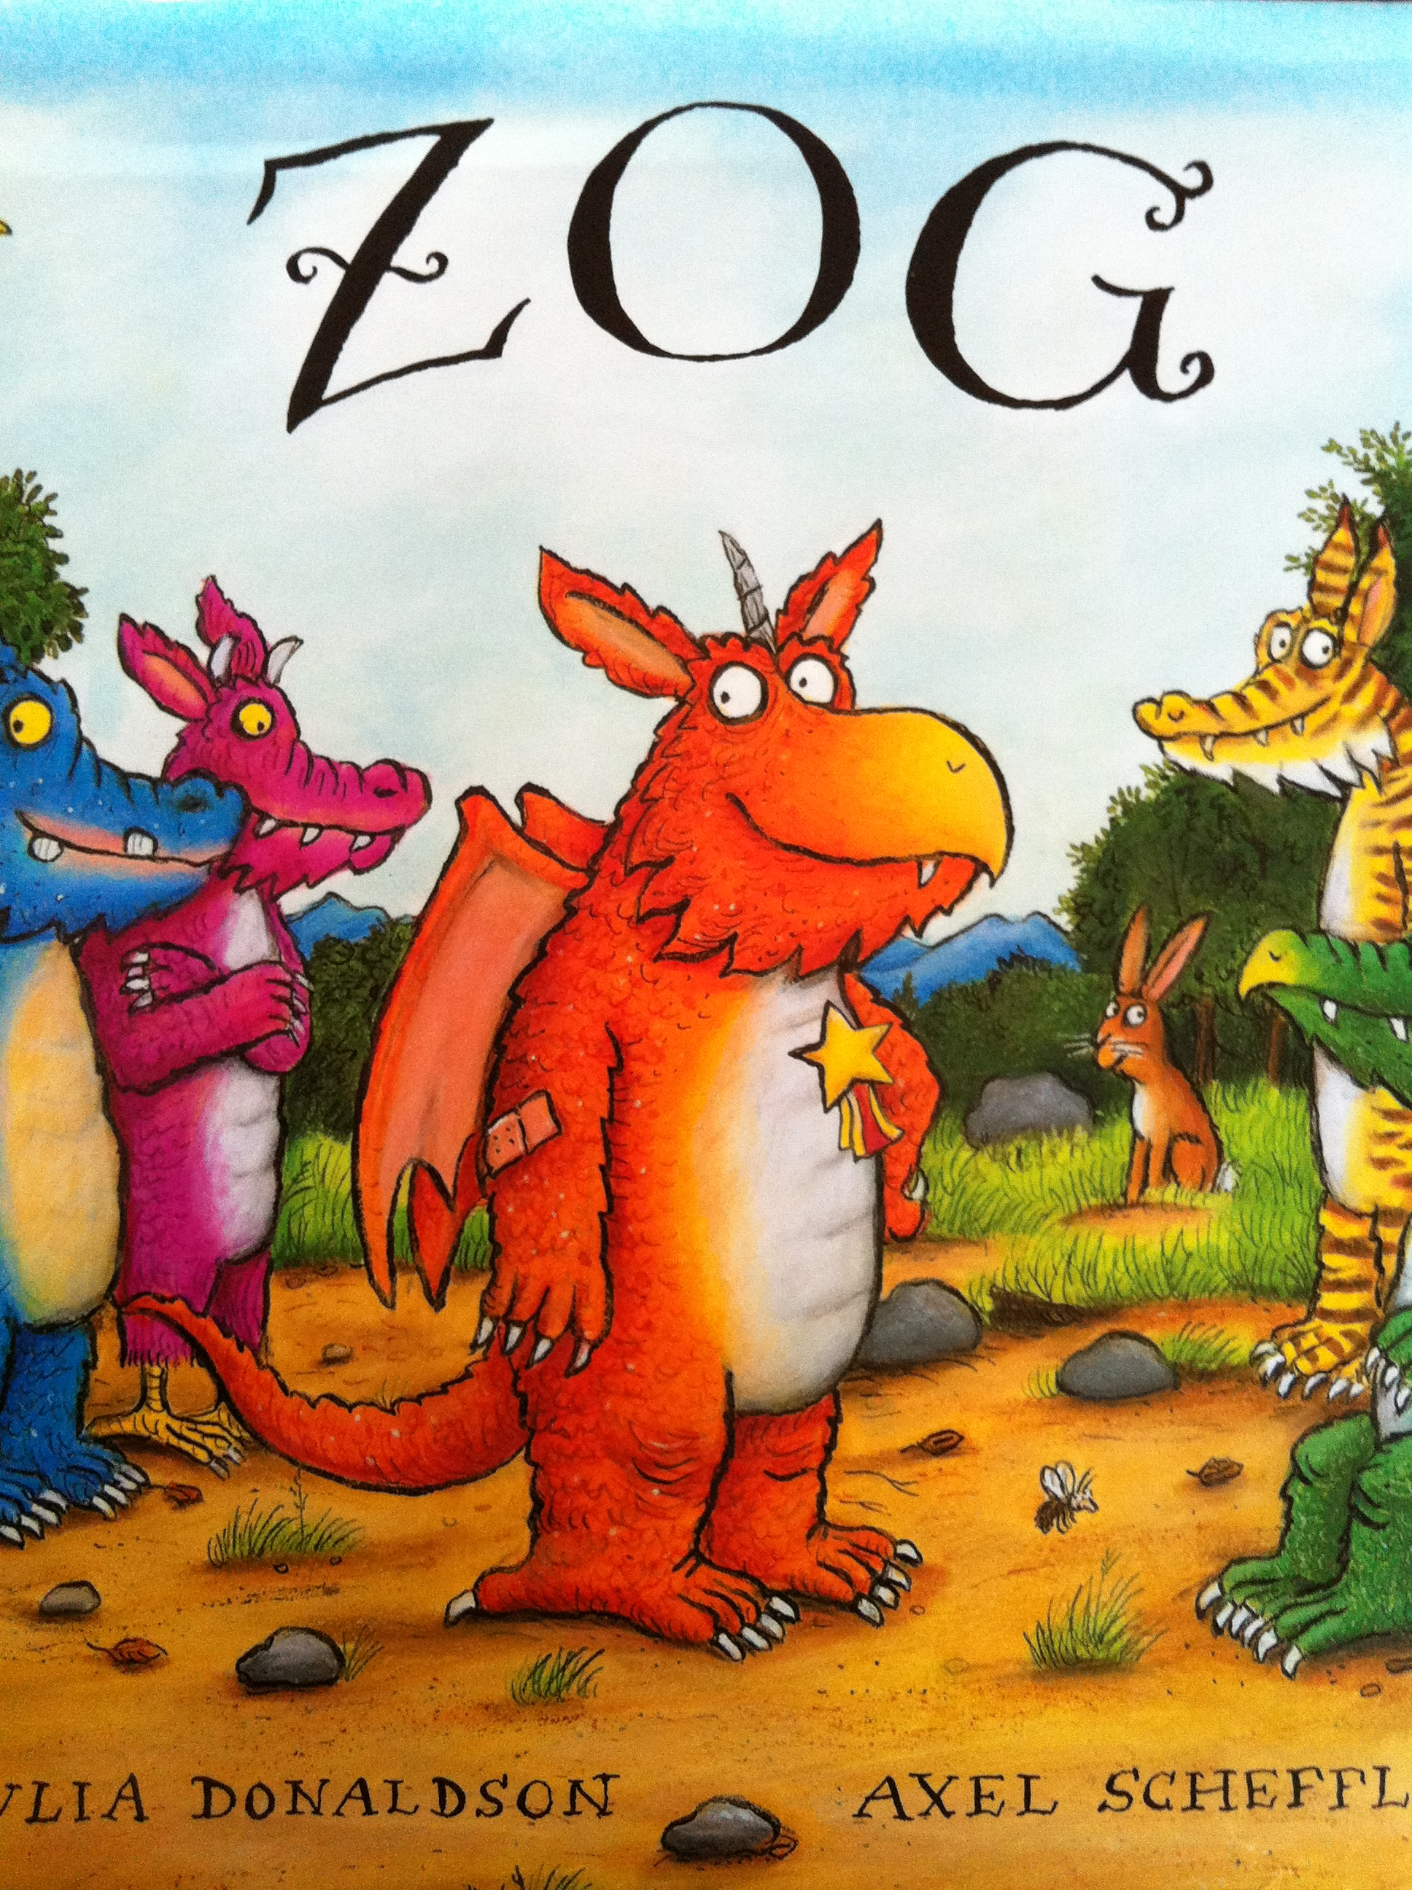
Lost and found
Zog
Bumpus Jumpus Dinosaurumpus
Supertato

Maths
This half term we will be will be looking at number bonds to 5 as well as comparing mass and capacity.
Please help your child by using words such as add, altogether, total, equals, makes, less, take away, more, bigger, smaller, numerals, heavy, light, full, empty.

Songs and Rhymes


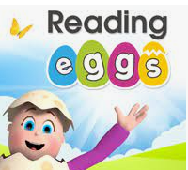
Useful Apps
Reading Eggs
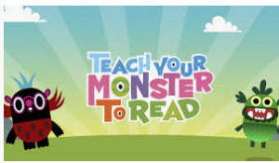
Meet the Alphablocks (Free)
Teach Your Monster to Read
Topmarks website
https://www.topmarks.co.uk/
Please remember:
- To bring your book bag every day; reading books will be sent out on a Monday and must be returned on a Friday. Please read with your child at least 3 times a week and record this in their reading record.
- To write your child’s name inside all of their uniform, including coats, hats, gloves and PE kits.
- To send your child in a warm coat, hat and scarf to school, now the weather is colder.
- Homework will be given on a Friday and will need to be returned by the following Monday.
- PE is on a Friday. Please send your child into school that day wearing black shorts/ leggings/ jogging bottoms, a white t shirt, school sweatshirt and trainers. Earrings must be removed.
- To have a look at our school website for the school holiday list and other useful information :
cheetwood.manchester.sch.uk

