Pupil Voice Day 2019
Feedback and Summary
The Great British Spring Clean was held from 22 March - 23 April 2019.
The school’s clean up event was registered with the Keep Britain Tidy website and the results of our clean up were logged with a cumulative total for the UK.

During the clean-up period, collectively we:
- Took part in 17,097 clean-ups
- Collected 957,377 bags of litter (around 39% will be recycled)
- Spent 1.1 million hours litter picking

The pupils received a certificate as a thank you for their participation in the event. They were all really well behaved and organised, safety conscious and eager to participate. School won a competition prize of £200 of eco equipment for its efforts.

Each class completed questionnaires based on their attitudes to litter and the results are summarised below:
Question One – The children’s perception of the litter situation at our school:
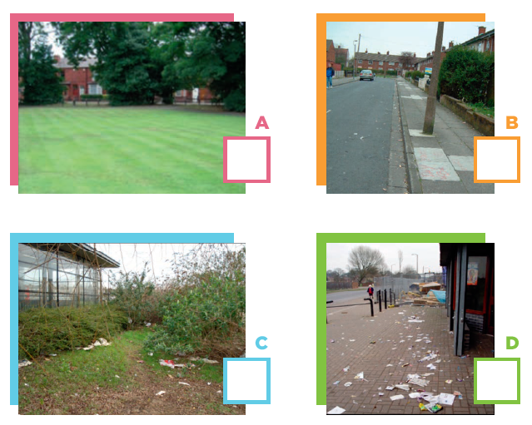
Children’s responses:
- A – 4%
B – 5%
C – 27%
D – 64%

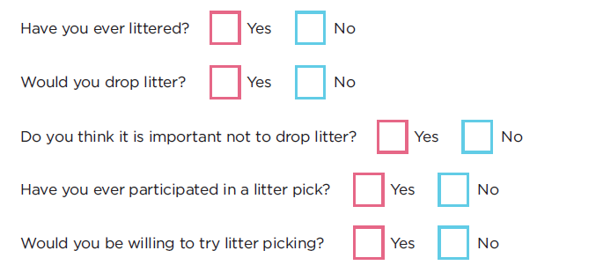
Children’s responses:
2) Y – 42% N – 58%
3) Y – 36% N – 64%
4) Y – 73% N – 27%
5) Y – 14% N – 86%
6) Y – 73% N – 27%

Children’s responses:
7)
A) 6%
B) 67%
C) 27%
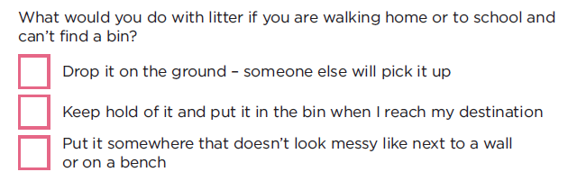
Children’s responses:
8) Y – 93% N – 7%
9) 1-2 – 4%
2-10 – 77%
10+ - 19%
10) Y – 95% N – 5%
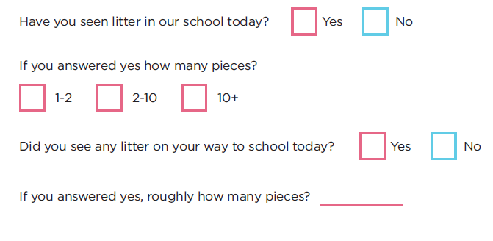
Each class was also asked to discuss and share/present ideas on how to improve our school grounds as part of pupil voice. Each class presented excellent work and ideas. A summary of the children’s ideas are below:
- Improving the playground with more toys/structures to play on
- Planting seeds and vegetables – gardening club
- Having an eco crew and more frequent litter picking
- More activities to do at break times and lunches
- More bins
Future actions to be implemented, based on the pupils’ ideas:
- Urban Crew/Eco Crew
- Gardening club
- Litter picking on a more frequent rotation
- Walk to School Week – w/c 10th June 2019

