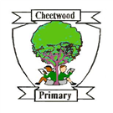Cheetwood Primary School

Online Safety Newsletter

Sept 2020

Google Family Link
Does your child use an Android device? Then you may like to set up Google Family Link, which allows you to set digital ground rules for your child. Once set up, you will be able to view your child’s activity so you can see what they are accessing and how long they are spending on each app (including setting time limits and adding a bedtime), manage in app purchases and hide specific apps from them as well as being able to remotely lock their device. If the device is connected to the internet, then you can also locate the device.

More information can be found here: https://families.google.com/familylink/

Discord

What is Discord?
Discord is a social networking app (rated as 13+ by the App store) that is used by gamers to chat to each other. Discord can be freely accessed via a website or app but does include in app purchases through Discord’s premium subscription service.

How does it work?
Discord is made up of ‘servers‘, which are spaces for groups of friends to chat, upload files and share images etc. Anybody can set up a server and they can either be public or private. Users have the ability to video call and send direct messages to either other individuals or to groups of up to 9 people. By default, all direct messages are scanned and explicit content is blocked.

How can I make it safer?
Discord have created this article, which outlines four steps to creating a safer account, including how to block users.
https://discord.com/safety/360043857751-Four-steps-to-a-super-safe-account

How is it linked to other games?
Children who play online games such as Fortnite may use Discord to chat about the game. Some gamers use Discord to chat when playing certain rather than using the in-game chat feature.

What do I need to be aware of?
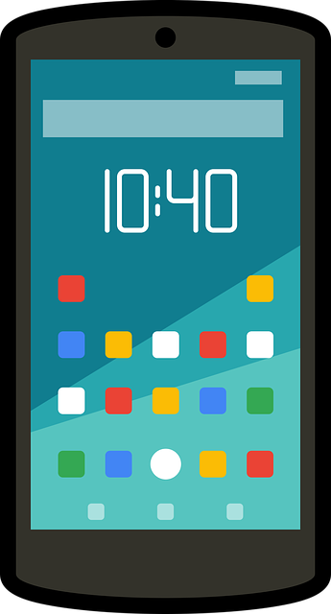
Discord should only be used by those over the age of 13. We always encourage you to chat to your child to see why they use different apps/websites and ensure that they know how to block users and what to do if they see any inappropriate content. It’s important to be aware that Discord does include video/voice calling which cannot be filtered.

Further information
These articles provide you with further advice illustrating the safety and reporting features:
https://parentzone.org.uk/article/discord-everything-you-need-know-about-chat-service
- https://www.net-aware.org.uk/networks/discord/
Users of this guide do so at their own discretion. No liability is entered into. Current as of the date released 1.9.20.

An overview
YouTube

New Child Online Protection guidelines

The UK Safer Internet Centre have helped to release the new ITU (International Telecommunication Union) Child Online Protection guidelines.

They have produced resources for children across three age categories to enhance their understanding of how to manage risks online as well as guidelines for parents about the potential risks your child may encounter online.

https://www.saferinternet.org.uk/blog/uksic-partner-itu-release-new-child-online-protection-guidelines

What is YouTube?
YouTube lets you watch, listen, stream, create and comment on videos. YouTube is intended for users over the age of 13, however the App store rates YouTube as 17+ due to the content that can be found on there.

How can I make YouTube safer?
There are some steps that you can take to make it a safer environment for your child:
- Turn on Restricted mode – this mode restricts the availability of mature content. You will need to set up a Google account to do this. Once set up, you can find this setting in options.
- Sit with your child and see what they are watching or set rules that devices should only be used in family areas.
- Ensure your child knows how to report inappropriate content.
- Make sure your child understands that they can talk to you if they see anything that makes them feel uncomfortable online.

BT: Skills for tomorrow

BT Skills for tomorrow incorporates a wide range of free courses such as How to support your child's Online Wellbeing, Video Calling and Parental Controls.

https://www.bt.com/skillsfortomorrow/home-life

YouTube Kids
YouTube recommend that YouTube Kids is used for children under the age of 13 as it provides a safer environment and offers greater controls such as being able to customise your child’s viewing (you can select the shows that you would prefer your child to watch). Use this link to find out how to set up the parental controls on YouTube Kids. https://support.google.com/youtubekids/answer/6172308?hl=en-GB

Posting videos
To post videos on YouTube, you should be over 13 years of age. Talk to your child about posting videos, do they understand what information they should keep private and what to do if they receive any negative comments? YouTube have produced these tips for those that do upload content: https://support.google.com/youtube/answer/2802244?hl=en-GB

Video Game database

Do you want to find out more about the games your child is playing or looking for game recommendations? This is a great website where you can search games by a number of ways e.g. by PEGI rating, genre or by those that do not have in-app purchases.

https://www.taminggaming.com/home

Further Guidance
- https://www.net-aware.org.uk/networks/youtube/

