Cheetwood Primary School

February 2021

Online Safety Newsletter

Are you back to helping your child learn at home? We hope this article will provide you with some useful pointers.

Learning online
- Follow your school’s rules on communicating and only use those approved channels to communicate with your teacher/school.
- When participating in any live teaching try to do this in a family area.
- Ensure appropriate clothing - no pyjamas etc.
- Set scheduled breaks from screen time.
- Only use web resources that your school have recommended or known reliable sources.

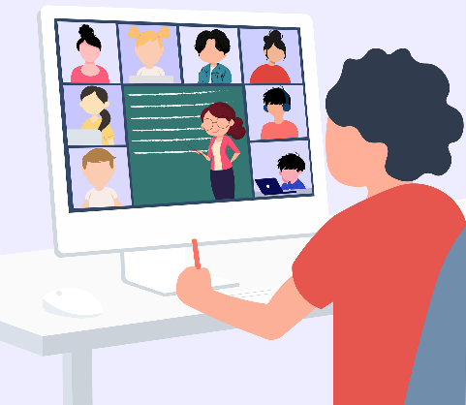
Keeping in touch
Is your child using a Conferencing app as part of keeping in touch with school such as Microsoft Teams, Google Meet or Zoom? This article provides you with some general advice to help you keep your child safe as well as further links tailored specifically to the app/platform they may be using:
https://www.net-aware.org.uk/news/keeping-kids-safe-on-conferencing-apps/

Test your Internet
Whilst no system is 100% perfect, filtering can reduce the possibility of your child seeing content that they shouldn’t. You can test your broadband or mobile connection here: http://testfiltering.com/personal/
Would you like to deliver online safety at home?
Here are some video guides to try:
https://www.thinkuknow.co.uk/parents/Support-tools/presentations-for-parents/

Screen time
As children are at home learning, there may be an increase in how long your child is spending online. This site offers age appropriate guidance relating to screen time and how you can balance it and set boundaries. https://www.internetmatters.org/issues/screen-time/

Do you need further support?
ParentZone have produced a list of support services, helplines and reporting channels that you may find useful:
https://parentzone.org.uk/article/where-report-and-get-support-during-lockdown
Users of this guide do so at their own discretion. No liability is entered into. Current as of the date released 1.2.21.

Safer internet Day

Safer Internet Day 2021 will be celebrated around the world on Tuesday 9th February. The global theme is ‘together for a better internet’. The focus is how young people can tell fact from fiction. You can get involved by visiting their website which has lots of advice, activities and films.

https://www.saferinternet.org.uk/safer-internet-day/safer-internet-day-2021/i-am-parent-or-carer
WhatsApp

You must be at least 16 years old to register for and use WhatsApp.
WhatsApp is a free messaging app that allows you to send messages and videos. One of the main features is that it has a Group chat function that are set up by one person (who is the admin). Everybody in the group, even if they’re not one of your child’s phone contacts, will be able to see all messages. If your child is added to a group with someone that they have previously blocked, that person can still see their messages and send them messages through the group. In settings, you can change who can add your child to groups, for example, you can change the settings to ‘my contacts’, which means that only those in your child’s contacts can add them to a group (those not in their contacts will have to send them an invitation to add them first).
Roblox

PEGI have rated Roblox PEGI 7 which means it is not suitable for persons under 7 years of age. However, remember a PEGI rating does not take into consideration the presence of a chat facility.

What should I be aware of?

Chat Facility: Players can chat to each other, you can add parental controls to turn this feature off completely or add restrictions. Further information can be found here: https://corp.roblox.com/parents/

Blocking users and reporting – ensure your child knows how to do this.

Virtual Currency - Players can buy Robux (their virtual currency) to buy in-game upgrades or accessories. If you do not want your child to purchase them ensure your card details are not saved.

SWGfL have produced this Privacy and Safety Checklist:
https://swgfl.org.uk/assets/documents/roblox-checklist.pdf

Common sense Media have also produced this Ultimate Guide to Roblox which details further information that you need to know: https://www.commonsensemedia.org/blog/parents-ultimate-guide-to-roblox-0

WhatsApp has been used in instances of online bullying, for example sending nasty messages or sharing images of other children without their permission to embarrass them. We need to ensure we talk to our children about being kind online. Encourage them to think about their digital footprint by thinking about the things that they say, do and share online. We also need to lead by example and model the type of behaviour expected online. This is a really useful article to help support your child online and how to be a positive role model: https://youngminds.org.uk/find-help/for-parents/parents-guide-to-support-a-z/parents-guide-to-support-social-media-and-the-internet/

It’s also important to note that WhatsApp has a live location feature which allows you to share your real-time location for a specific amount of time. You can change your options in settings to never share your location. If your child is using WhatsApp, then show them how to block and report contacts and remind your child that they should talk to you or another trusted adult if they have any concerns.

Further information
- https://www.whatsapp.com/safety/
Grand Theft Auto

Is your child using Discord?
As with any site that includes a chat facility, there are risks involved. Learn more about Discord here and help your child to use it safely:
https://parentzone.org.uk/article/discord-everything-you-need-know-about-chat-service
Grand Theft Auto

Grand Theft Auto, depending on which version played, is rated 18+ by PEGI, often because of language, glamourisation of crime and the depiction of drugs. GTA is not suitable for those under this age. Find out more about GTA here:
https://www.net-aware.org.uk/networks/grand-theft-auto-san-andreas/

